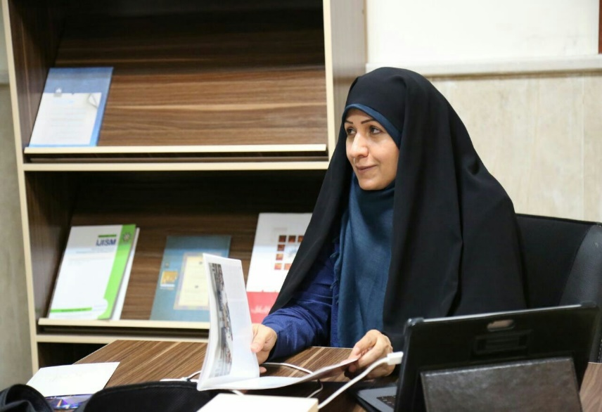

**Personal information**

|  |
| --- |
| Dr. Masoumeh Esmaeili |
| professor of Department of Counselling, Faculty of Psychology and Education Allameh Tabataba'i University |
| **Research Interests:**Foundations and principles of Islamic contribution and ontology; Sociological studies in different aspects of personal, family, local, and national identities. |
| **Email Address**: esmaeili@atu.ac.ir |
| **Contact No**.:+9821 4839 3271 |
| **Address**: Allameh Tabataba'i University, Varzesh Sq., Dehkadeh Olympic, Tehran, Iran. |

The title of the activity

|  |  |
| --- | --- |
| President of the Iranian Consulting Association for 2 consecutive terms | 1 |
| Writing more than 160 scientific research articles and ISI and 70 articles in national and international conferences | 2 |
| Top researcher of 2010 and top researcher of 2014 and top translator of 2011 | 3 |
| Owner of a free-thinking chair "family the Sahm model" and a critic of free-thinking chairs | 4 |
| member of the psychology working group of the Transformation Council (revision and compilation of undergraduate course topic) | 5 |
| Judge of the 4th International Khwarazmi Festival and Farabi Festival | 6 |
| Selection of Iranian female heroes from the point of view of the organizers of Ammar People's Film Festival | 7 |
| Guidance for 251 theses and dissertations | 8 |

|  |  |
| --- | --- |
| Compilation of the establishment counseling model of the immigrant’s identity status based on "returning to oneself" extracted from the metaphors of masnavi manavi stories. | **2023** |
| Compilation of the establishment counseling model of the immigrant’s identity status based on" returning to oneself" extracted from the metaphors of masnavi manavi stories. | 2023 |
| The pattern of childbearing motivation is based on the lived experiences of families with at least one child | 2023 |
| Compilation of the establishment counseling model of the immigrant’s identity status based on" returning to oneself" extracted from the metaphors of masnavi manavi stories. | 2023 |
| The consulting model of "I" agent based on the view of Allameh Mohammad Taghi Jafari | 2023 |
| Evaluation of the effectiveness of group counseling with a share approach contribution Pattern Islamic ontology in promoting responsibility and adjustment of young girls | 2022 |
| Investigating the identity changes of mothers in the face of empty nest. | 2022 |
| Dimensions of aging in Iranian women: A phenomenological study. Journal of Psychological Science. | 2021 |
| The process of transferring moral components from parents to adolescent children: A qualitative study. | 2021 |
| Promoting the Way of Life Towards Promoting Happiness (based on Islamic Lifestyle with Emphasis on Rumi's Spiritual Masnavi | 2021 |
| Phenomenology of parent-child conflict management during the coronavirus outbreak. Rooyesh | 2021 |
| A Model of Premarital Counseling for Police Personnel Based on Marital Consent. | 2021 |
| Developing A Model of Iranian Family Resilience: A Qualitative Research. | 2020 |
| Qualitative Study of the Role of the Language in Satisfactory Couple Relationships: A Study in grounded Theory | 2019 |
| Effectiveness of counseling model based on Asma-hosna in marital quality of married women. | **2017** |
| The effects of mothers’ mindfulness training on children’s self-efficacy. | 2016 |
| Comparing the effectiveness of cognitive behavioral therapy (CBT) and interpersonal psychotherapy (IPT) for pregnant women to increase marital satisfaction. | 2015 |

**A number of recent articles :**

**A number of international articles:**

|  |  |  |  |  |
| --- | --- | --- | --- | --- |
| 1 | A Case Study based on the Model of “JAN Therapy”: A Psychotherapeutic Interpretation of Masnavi Manavi | I J C T A, International Science Press | ISI | 2015 |
| 2 | Efficacy of Life ReviewTherapy with Emphasis on Islamic Ontology on Life Expectancy Promotion in Infertile Women | ACTA MEDICA MEDITERRANEA | ISI | 2015 |
| 3 | Necessity of developing a native model of performance improvement for counselors in schools across the country | International Journal of Psychology and Behavioral Research | ISI | 2014 |
| 4 | Damaging Factors of Schools Psychology and Counsel-ing Activities in Iran | Journal of Psychology and Behavioral Scienc | ISI | 2014 |
| 5 | Designing a native pattern | International Journal of Psychology and Behavioral Research | ISI | 2014 |
| 6 | Relationship of Primary Incompatible Schema and Perception of Aging among Elders in Ira | Academy of Applied Psychology | ISI | 2015 |
| 7 | Planning and preparation model to enter the adolescent s life cycle stage based on successful and unsuccessful families experience | Medwell MJ Journals | ISI | 2016 |
| 8 | A Theoretical Framework of the Divorcing Iranian Couples Experience: A Grounded Theory Study | Journal of Research & Health | ISI | 1394 |
| 9 | Effectiveness life review on life satisfaction | Open journal of psychiatry | ISI | 2016 |
| 10 | A Study of the Effectiveness of Life Review therapy with Islamic Ontological Orientation on the Parent-child 98Relationships in Adolescents | I J C T A, International Science Press | ISI | 2015 |
| 11 | RelationshipBetweenDimensionsof PerceivedSocialSupportand DesireforMarriageAmongAcademicStudents | ShirazE-MedJ.InPress(InPress):e86642 | ISI | 2019 |

**A number of international conference articles**

|  |  |  |  |  |
| --- | --- | --- | --- | --- |
| 1 | Morita therapy in reducing the anxiety in infertile women | Iranian Journal of Reproductive Medicine | international | Tabriz-18 Congress of Iranian Society for Reproductive Medicine |
| 2 | A SURRVEY OF THE INFLUENCE OF LIFE REVIEW ON REDUCING THE RATE OF ANXIETY IN CHILDREN OF THE DIVORCED FAMILIES. | INTERNATIONAL CONFERENCE ON NEW TRENDS in education | international | Antalya – Turkey |
| 3 | THE FOSTERING OF CREATIVITY IN THE ELEMENTARY SCHOOL: CHALLENGE OR CHANCE? | INTERNATIONAL CONFERENCE ON NEW TRENDS | international | Antalya – Turkey |
| 4 | Development of Instructional pattern on self healing elements and Islamic humanistic(based on javdi amoli) and Effectiveness on Life Satisfaction | The Second Asian Conference on Psychology & the Behavioral Sciences | international | The Ramada Osaka, Osaka, Japan |
| 5 | Efficacy of life review with emphasis on Islamic ontology on PTSD | INTERNATIONAL INSTITUTE FOR MUSLIM UNITY(مقاله تمام) | international | Malaya/2011 |
| 6 | INTERRELATIONSHIP BETWEEN PARENTINNG | Science direct(مقاله تمام) | international |  |
| 7 | THE EFFECTIVENESS OF GROUP COUNSULTATION | Science direct(مقاله تمام) | international |  |
| 8 | The effectiveness of training emotional intelligence via Assimilation and Accommodation introspection method on maturity of judgment disposition of critical thinking | 2015 International Conference on Social Science and Contemporary Humanity Development | international | Hubei, china |
| 9 | A case study based on the model of "Soul therapy":a psychotherapeutic interpretation of Masnavi Manavi | International Conference on Social Science and Contemporary Humanity Development | international | Hubei, china |
| 11 | Efficacy of Life Review Therapy with Emphasis on Islamic Ontology on Decreasing PTSD Symptoms | The Neuroscience Journal of Shefaye Khatam | international | Tehran, Iran |